Moving Violations Exploratory Analysis

A. Casey, April 21 2021

Contents

Key Takeaways 1

Violations per Capita 2

Grouping Violations 3

Road Types Where Violations Occurred 6

Fines 7

# Key Takeaways

* Wards 5, 7 & 8 have the most moving violations per capita, more than twice the rate of any of the other 5 Wards.
* Secondary Conduct Violations (not immediately dangerous to others) are highest per capita in Wards 7 & 2. They are lowest in Wards 3 & 4.
* A list of the unique violation types and their designated categories are given in the csv file “Violation_Categories.csv”
* 38% of violations had a fine issued but no payment. This varies from 21 to 51% among wards, with wards 7 & 8 being the highest.

**Data Improvements**

* Data on road type (arterial, local, etc) missing unevenly across wards – e.g. its unknown what type of road 95% of violations happened on in Ward 3, but just 5% in Ward 4.
  + Suggestion: Need link the type of road based on other data in database

# Violations per Capita

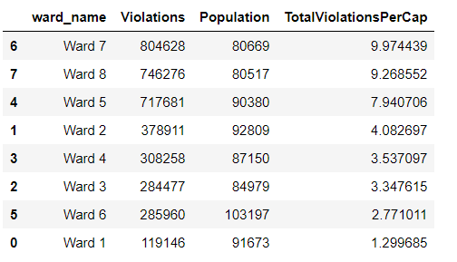

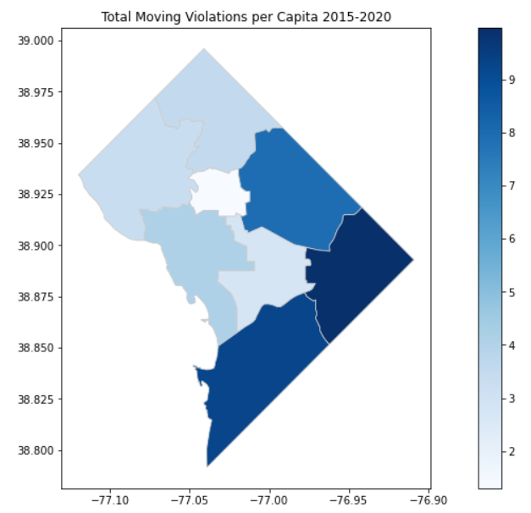

# Grouping Violations

How unique violations were categorized. These categories and their criteria stand to be refined.

D: Immediately Dangerous to Others

Dangerous driving behavior that is obviously in violation of traffic laws e.g. speeding, improper turning

S: Secondary Conduct Violations

Violations that are not obvious from driver behavior (e.g. no insurance) or pertain to the drivers vehicle (e.g. broken headlights)

MISC: Miscellaneous

Commercial, truck, taxi violations, etc

**Per capita violations by violation type, 2015-2020:**

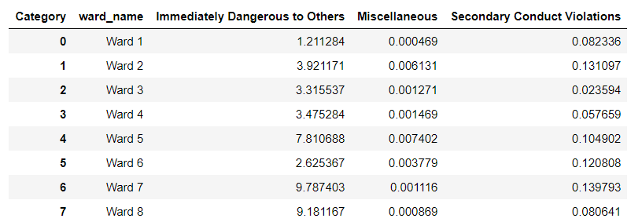

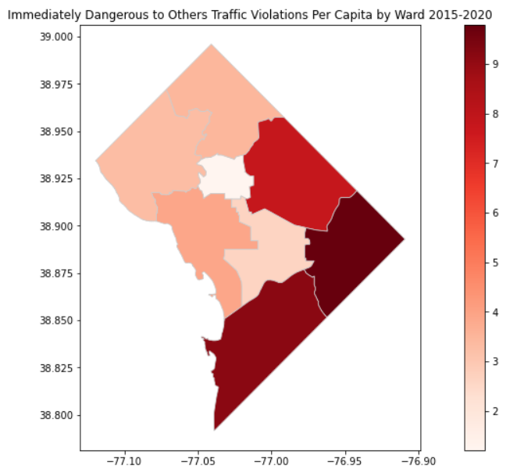

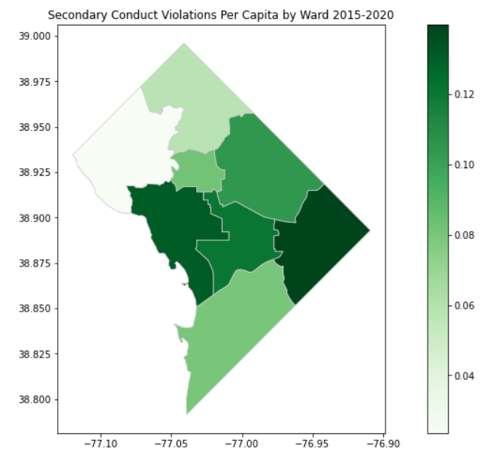

# Road Types Where Violations Occurred

*Sorted by % Unknown*

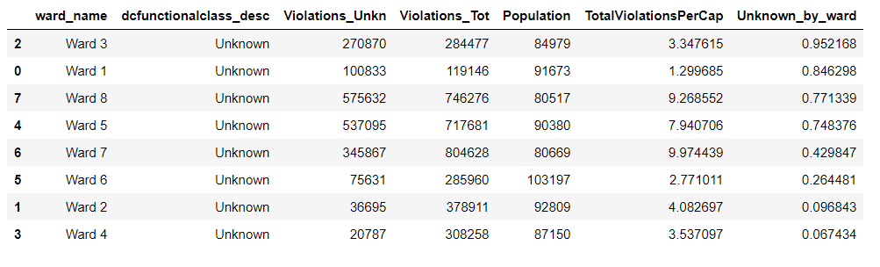

Unfortunately, the number of unknown road types is extremely spread out across wards - accounting for 95% of incidents for ward 3 and just 6 % for ward 4, with all the other roads scattered in between. In order to normalize the violations by road type, we would need to fill in this information.

# Fines

